Caitlyn Jones
Prof. Yangyang Wang
MATH 40A: Intro to Applied Math
25 September 2024
Homework 1

  - To create array p, I first created a variable p_values that will hold the 51 evenly spaced values of p from 0.5 to 1. Then, I created array p using p_values.
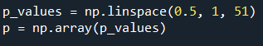

  - To create arrays S1 and S3, I created a function P(N,m) that will create the formula for binomial distribution, which is
$P\left(N,m\right)=\frac{N!}{\left(N-m\right)!m!}p^{m}{(1-p)}^{N-m}$ .
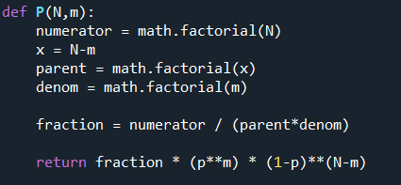

Then, I created arrays S1 and S3 based on the formulas
$S\left(p,1\right)=P\left(1,1\right)$ and $S\left(p,3\right)=P\left(3,3\right)+P\left(3,2\right)$
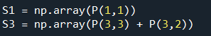
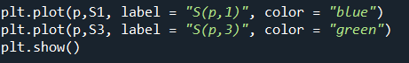
  - To graph these arrays, I created a graph to plot S1 vs p and S3 vs p.

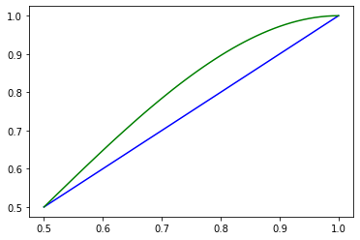
  - Lastly, I added a legend so that anyone viewing the graph can easily identify what is happening.
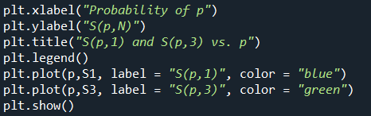

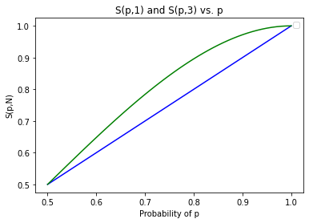

  - To successfully compute the factorial of any number using function my_factorial(n), I created variable factorial = 1 inside the function, since every factorial ends with multiplying the rest of the factorial by 1. Then, I used a for loop to iterate through each number from 1 to n+1 (since the range is not inclusive of n, the range must be 1 to n+1) and multiply that number by the variable factorial.
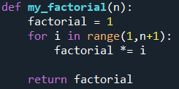


Next, I used math.factorial(n) to make sure that my_factorial(n) produces the same answer.
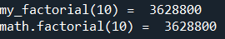

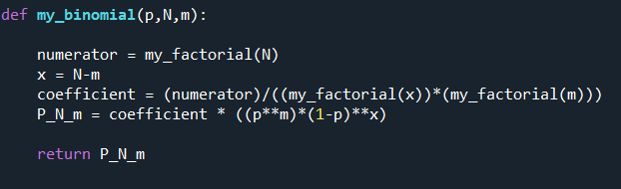
  - To create the function my_binomial(p,N,m), I broke down the binomial $P\left(N,m\right)=\frac{N!}{\left(N-m\right)!m!}p^{m}{(1-p)}^{N-m}$into 3 different variables: numerator, x, and coefficient. With these three variables, I then computed the formula for P(N,m).

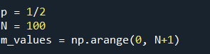
  - To plot P(N,m), I created three variables: p = ½, N = 100, and m_values which contains values for m from 0 up to N (again, using N+1 because the range is exclusive of the last digit entry in the range).

Then, I created an array binomial_values that will contain the computation of my_binomial(p,N,m) for every m value from m_values.
Lastly, for my graph, m_values is the x-axis and binomial_values is the y-axis.
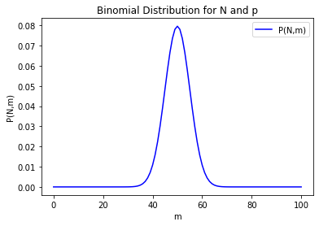
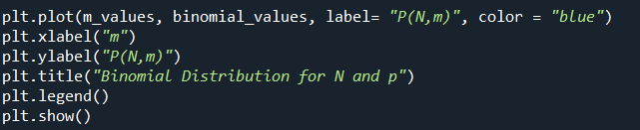
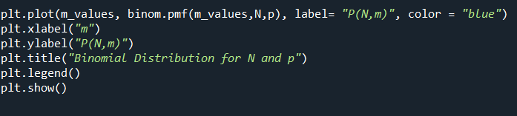
  - To check that my_bionomial(p,N,m) outputs the same graph as the Scipy module, I graphed m_values as the x-axis and binomial distribution function in Spicy as the y-axis. The results are the same!
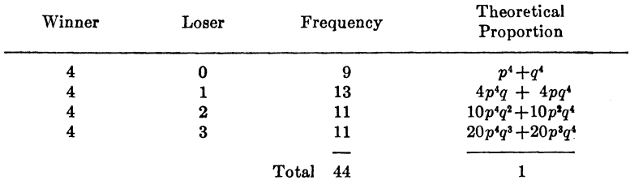
Given the above table, imagine each line is labeled 1-4. Following are the equations of theoretical proportions using $P\left(N,m\right)=\frac{N!}{\left(N-m\right)!m!}p^{m}{(1-p)}^{N-m}$ with $q=(1-p)$.
Line 1:
$$P\left(4,4\right)+P\left(4,0\right)$$
$$\frac{4!}{\left(4-4\right)!4!}p^{4}q^{4-4}+\frac{4!}{\left(4-0\right)!0!}p^{0}q^{4-0}$$
$$p^{4}+q^{4}$$
Line 2:
$$P\left(5,4\right)+P(5,1)$$
$$\frac{5!}{\left(5-4\right)!4!}p^{4}q^{5-4}+\frac{5!}{\left(5-1\right)!1!}p^{1}q^{5-1}$$
$$5p^{4}q+5pq^{4}$$
However, because there are only 4 instances where the winning team wins 4 and losing team wins 1, so we can subtract one instance from $P\left(5,4\right) and P(5,1)$.
So, the final equation will be $4p^{4}q+4pq^{4}$.
Line 3:
$$P\left(6,4\right)+P(6,2)$$
$$\frac{6!}{\left(6-4\right)!4!}p^{4}q^{6-4}+\frac{6!}{\left(6-2\right)!2!}p^{2}q^{6-2}$$
$$15p^{4}q^{2}+15p^{2}q^{4}$$
Following the same logic for line 2, we can subtract 5 cases from each instance to get
$$10p^{4}q^{2}+10p^{2}q^{4}$$
Line 4:
$$P\left(7,4\right)+P(7,3)$$
$$\frac{7!}{\left(7-4\right)!4!}p^{4}q^{7-4}+\frac{7!}{\left(7-3\right)!3!}p^{3}q^{7-3}$$
$$35p^{4}q^{3}+35p^{3}q^{4}$$
But with subtracting 15 cases, we get
$$20p^{4}q^{3}+20p^{3}q^{4}$$

  - Given $S(p,7)$, we get the following formula
$$S\left(p,7\right)=P(4,4)+P\left(5,4\right)+P\left(6,4\right)+P(7,4)$$
$$S\left(p,7\right)=p^{4}+{5p}^{4}q+15p^{4}q^{2}+35p^{4}q^{3}$$
We can plug (1-p) back into q to get
$$S\left(p,7\right)=p^{4}+{4p}^{4}(1-p)+10p^{4}{(1-p)}^{2}+20p^{4}{(1-p)}^{3}$$
  - With p = 0.65, we get the following
$$S\left(0.65,7\right)={(0.65)}^{4}+{4\left(0.65\right)}^{4}(1-0.65)+10{(0.65)}^{4}{(1-0.65)}^{2}+20{(0.65)}^{4}{(1-0.65)}^{3}$$
$$S\left(0.65,7\right)= .800$$
Therefore, the winning team wins 80% of the time.

